Site Name:Weather.org

Site Purpose: We plan on informing people about the weather that is happening in Arizona.

Target Audience: We plan on targeting young adults.

Sitemap: 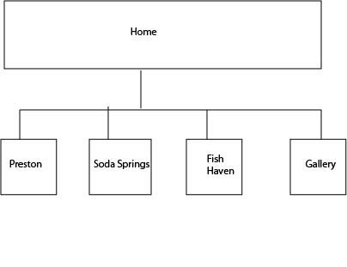

Color scheme: background color: #FFFFFF Box color: blue

Typography: Ariel Rounded MT BOLD